
Sec 1.1 -Analyzing Numerical Data
Fermi Problems: Estimating Large Numbers Name:
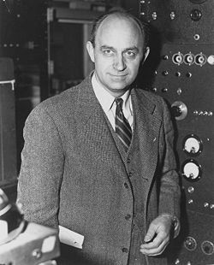
Enrico Fermi (1901 – 1954) was an Italian physicist that worked in the United States. He was known for his contributions in creating the first nuclear reactor and his work on the Manhattan Project (creating the atomic bomb). He received the Nobel Prize for his work in Physics in 1938. Fermi was also well known for this ability to make good estimates of large quantities with little actual data and using only a few logical assumptions. When determining these approximations, he would usually first try to determine reasonable lower bound and upper bound limits of the estimate. Then, he would make logical assumptions and work towards finding a reasonable estimate (usually by some power of 10) within the earlier defined limits. A question he would commonly pose while lecturing at the University of Chicago was, “How many piano tuners are there in the city of Chicago?” Today, making such estimates of large quantities are commonly referred to as Fermi Problems.

Let’s try a few.

How many Skittles?
How many skittles candies can fit in a mason jar that has the inner dimensions that are approximately a cylinder with a height of 9 cm and a base radius of 3 cm?
(Reminder: Cylinder’s Volume = $π∙r^{2}∙h$).

1. What would you decide is a reasonable lower limit for the number of skittles in the jar? (i.e. a number of skittles that you are certain there are at least that many in the jar)

2. What would your group decide is a reasonable upper limit for the number of skittles in the jar? (i.e. a number of skittles that must be more than the maximum amount of skittles in the jar)

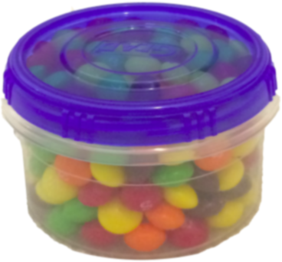
3. What would you decide is a reasonable lower limit for the number of skittles in the container?

4. What would your group decide is a reasonable upper limit for the number of skittles in the container?

Assume that the container is roughly a rectangular prism such that Rectangular Prism Volume $=l∙w∙h$

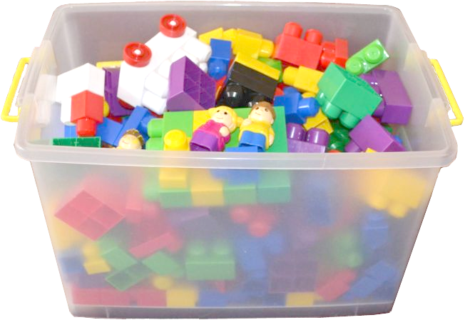
5. What would you decide is a reasonable lower limit for the number of blocks in the container?

6. What would your group decide is a reasonable upper limit for the number of blocks in the container?

p.1

AMDM Student Worksheets Created By Matthew M. Winking at Phoenix High School SECTION 1-1

For a little more precision in our estimates we can run some trials and use empirical ratios
7. Consider the investigational data found by filling the following containers with skittles.

A few students conducted a study of some solids and found the following container
(solid #1) held 192 skittles.
5cm
4 cm
4 cm
A few students conducted a study of some solids and found the following container (solid #2) held 258 skittles.

3 cm

3 cm
12 cm

Fill out the following table: | Solid #1 | Solid #2
Number of Skittles :
Volume:
Ratio $\left(\frac{Skittles}{{cm}^{3}}\right)$:

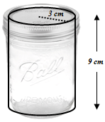
Using the empirical ratios above determine more precisely, how many skittles candies can fit in a mason jar that has the inner dimensions that are approximately a cylinder with a height of 9 cm and a base radius of 3 cm?
(Reminder: Cylinder’s Volume = $π∙r^{2}∙h$).

8. Consider the investigational data found by filling the following containers with skittles.

A few students conducted a study of some solids and found the following container
(solid #1) held 32 jellybeans.
5cm
4 cm
4 cm
A few students conducted a study of some solids and found the following container (solid #2) held 43 jellybeans.
12 cm
3 cm

3 cm

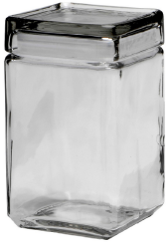

Using the empirical data approximate how many jellybeans the candy jar at the right will hold if it is approximately a rectangular prism with the inner dimensions 12 cm by 14 cm by 28 cm.
28 cm

12 cm
AMDM Student Worksheets Created By Matthew M. Winking at Phoenix High School SECTION 1-1

p.2

14 cm
A student was conducting a study to determine how many pages he would need for the book he is writing. So, he found that the following number of words fit on each type of the following papers using an 11 point font:

Paper Size | Average Number of Words
8.5 inches by 11 inches | 800
5.5 inches by 6.5 inches | 300
12 inches by 18 inches | 1900

- Using the collected data above what would be a reasonable rough estimate of the number of words per square inch of writing paper using an 11 point font?

- Roughly, how many pages would his book be if his novel was approximately 65,000 words and he used a paper size of 5 inches by 7 inches with an 11 point font (i.e. how many page numbers would the book require just for the novel)?

A student was conducting a study to determine how many loose Navel oranges that could be packed in different box sizes at the local farmer’s market. The average navel orange had a diameter of 3.2 inches.

Box Dimensions | Number of Oranges in the Box
20 inch x 13 inch x 12 inch | 96 oranges
12 inch x 12 inch x 12 inch | 53 oranges
20 inch x 10 inch x 6 inch | 37 oranges

- Using the collected data above what would be a reasonable rough estimate of a ratio of how many cubic inches per orange?

- Given the Farmer’s Market wanted to use a box that had the dimensions, , approximately how many oranges should fit in the box based on the information provided by the table?

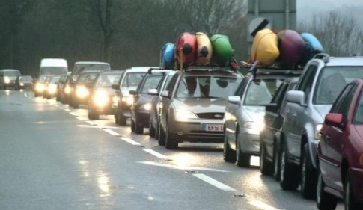
- On a highway a wreck occurred and caused an 10 mile traffic jam on one side of the road. The average car is 13.5 feet in length, the average truck is 20 feet in length, and the average 18 wheeler tractor trailer is 75 feet in length. 70% of the traffic jam consists of cars, 20% trucks, and 10% 18 wheeler tractor trailers. If the average distance between vehicles is 3 feet, how many vehicles are stuck in the traffic jam?

AMDM Student Worksheets Created By Matthew M. Winking at Phoenix High School SECTION 1-1

p.3

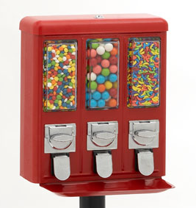
- A person just purchased the vending machine shown. Each compartment has the dimensions of 5 inches by 7 inches by 17 inches. Assuming the vending machine uses Gumballs that are approximately spherical and 1 inch in diameter, how many gumballs should fit in one of the compartments?

(Hint: Packing spheres in a rectangular prism usually take up 190% of the volume of the spheres.)
SHOW YOUR WORK

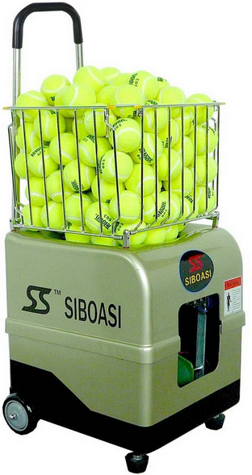
15. A person is using a new tennis ball launching machine that is 15 inches by 15 inches by 14 . Assuming the machine uses tennis balls that are spherical and 2.7 inches in diameter, how many tennis balls should fit in one of the top of the machine?
(Hint: Packing spheres in a rectangular prism usually take up 190% of the volume of the spheres using random packing.)
SHOW YOUR WORK

AMDM Student Worksheets Created By Matthew M. Winking at Phoenix High School SECTION 1-1

p.4

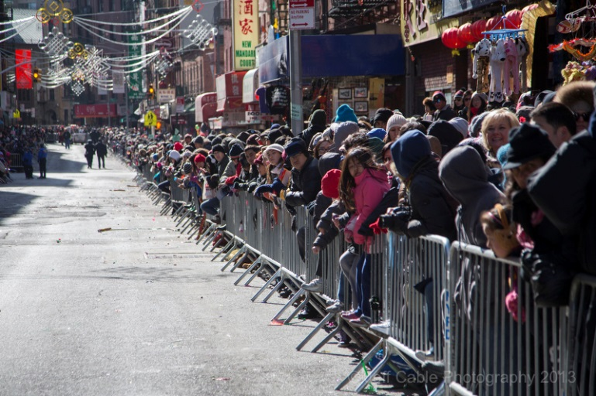
Estimating the number of people in a large crowd (for example watching a parade or attending/marching in a political rally) is quite challenging and often leads to controversies. One method sometimes used is to focus on a small section of the crowd, such as a rectangular area.

16. Mark off a 5 foot by 5 foot square, and see how many people can comfortably stand inside the square as if they are at an outdoor concert.
a. How many people fit?

b. Divide the area of the square by the number of people that fit inside the square and explain what this ratio means.

c. Use the ratio to estimate the size of a crowd that is 10 feet deep on both sides of a street for a mile and is filled with people.

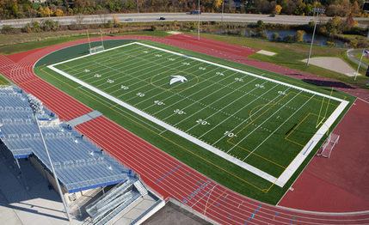
17. A football field is 360 feet long and 160 feet wide. The principal is making an evacuation plan for the school. How many students can the principal expect to fit on the football field in an emergency? (Remember the expected floor space a standing person occupies is about 2.5 sq feet)

AMDM Student Worksheets Created By Matthew M. Winking at Phoenix High School SECTION 1-1

p.5

